**Columbus: Hero or Villain?**

**DBQ**

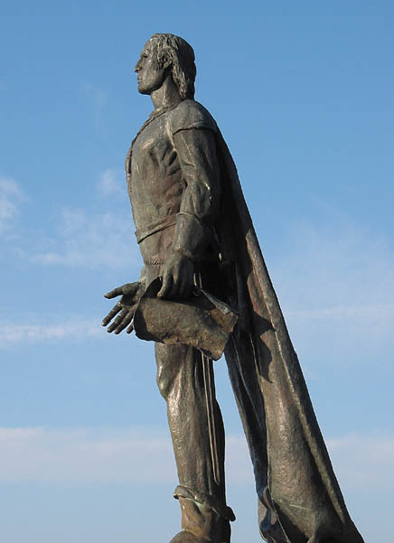

Topic Focus Question: *Should Columbus Day be Abolished as a National Holiday? (cite at least 4 documents to support your argument)*

Evidence: The following excerpts come from diverse sources and have been edited for the purpose of this activity. (Helpful Hint: Underline the words that display point of view of the author.)

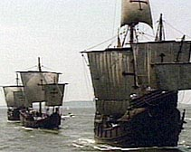

**Document 1**

The “Columbus Day” holiday is the only national holiday that is overtly insulting to millions of Americans. It is now universally understood that Christopher Columbus did not “discover” the American continent. That concept is a “Euro-centric” one that is deeply insulting to American Indians and many native-born Americans of all cultures. It is also historically incorrect. American Indian people have been on this continent at least 10,000 years, and scientists have proven that numerous other explorers had arrived on this continent from other parts of the world long before Columbus. It is also now known that many of the things we once believed about Christopher Columbus were myths, and that much of what we did not know about him would seriously tarnish his image, to say the least. This petition, however, is not meant to be an attack on Christopher Columbus, but rather an appeal for a holiday that is not insulting to any American.   
  
American national holidays should be days that bring a sense pride and togetherness for ALL Americans, and stem from an “American perspective.” “Columbus Day” fails that test on all counts. “First Americans Day” would be a holiday that would be meaningful to each and every American. It would be a holiday that would be from an “American perspective” rather from an “Euro-centric” one. And, finally it would be a holiday that would instill pride in us as a collective group of people, while still recognizing and honoring our differences. The concept is one that is a “win-win” for all Americans regardless of their heritage.

Source: Online Petition to “Abolish Columbus Day and Rename it.”

**Document 2**

**Timeline of Columbus Day:**

1792 a ceremony organized by the Society of St. Tammany, or Colombian Order was held in New York City honoring Columbus and the 300th anniversary of the landing.

Oct. 12 1866 out of the pride for their native son, the Italian population of New York organized the first celebration of the discovery of America.

1869 when Italians in San Francisco celebrated Oct. 12 they called it Columbus Day.

1892 President Benjamin Harrison proclaimed the 400th anniversary of the event.

1905 Colorado became the first state to observe a Columbus Day.

Since 1920 the day has been celebrated annually.

1937 President Franklin Roosevelt proclaimed every Oct. 12 as Columbus Day.

1968 President Johnson declared it a federal public holiday on the 2nd Mon. in Oct.

**Document 4**

The association between Columbus and America took root in the imagination" in the eighteenth century. "People had even more reason to think of themselves in distinctive American terms." (Noble, 250) Americans, searching for a history and a hero, discovered Columbus….

It is not hard to understand the appeal of Columbus as a totem for the new republic and the former subjects of George III. Columbus had found the way of escape from Old World tyranny. He was the solitary individual who challenged the unknown sea, as triumphant Americans contemplated the dangers and promise of their own wilderness frontier...as a consequence of his vision and audacity, there was now a land free from kings, a vast continent for new beginnings. In Columbus the new nation without its own history and mythology found a hero from the distant past, one seemingly free of any taint from association with European colonial powers. The Columbus symbolism gave America an instant mythology and a unique place in history, and their adoption of Columbus magnified his own place in history.

Source: John Noble Wilford, *Mysterious History of Columbus*

**Document 5**

"societies in fact reconstruct their pasts rather than faithfully record them" and do so "with the needs of contemporary culture clearly in mind."

Source: Michael Kammen, *Mystic Chords of Memory*

**Document 6**

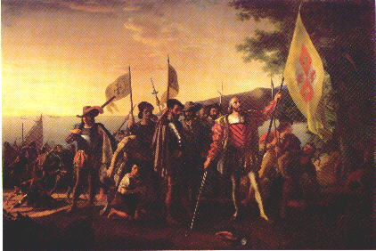

The Landing of Columbus by John Vanderlyn portrays the Age of Discovery. Commissioned by Congress the work hangs in the Capitol Building in Washington, D.C. opposite those painted by John Trumball.

**Document 7**

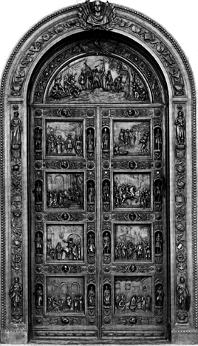

The Columbus Doors at the east entrance of the Rotunda are an imposing welcome to the heart of the gallery of national myths. Standing nearly 17 feet tall, and weighing 20,000 pounds, Randolph Roger's alto-relief bronze doors make a powerful statement about not only their subject, Christopher Columbus, but the importance of Columbus to the national consciousness.

**Document 8**

#### When he arrived on Hispaniola in 1508, Las Casas says, "there were 60,000 people living on this island, including the Indians; so that from 1494 to 1508, over three million people had perished from war, slavery, and the mines. Who in future generations will believe this? I myself writing it as a knowledgeable eyewitness can hardly believe it...."

#### Thus began the history, five hundred years ago, of the European invasion of the Indian settlements in the Americas. That beginning, when you read Las Casas-even if his figures are exaggerations (were there 3 million Indians to begin with, as he says, or less than a million, as some historians have calculated, or 8 million as others now believe?) is conquest, slavery, death. When we read the history books given to children in the United States, it all starts with heroic adventure-there is no bloodshed-and Columbus Day is a celebration.

#### Source: Howard Zinn, The People’s History of the United States