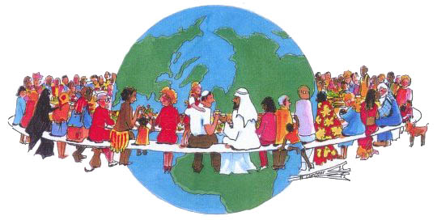
Cultural Travel Project
You will be creating a project to convince your classmates to travel to your chosen destination! Your project should include two portions. Firstly, you are to create a brochure for your country. This should include the information and topics listed below. Secondly, you are to create a video advertisement for your destination. The video can feature/star your group members, actors, celebrities, or can be edited featuring footage and images only. Your video advertisement should be taken seriously and include the information found in your brochure handout.
Your brochure should include the following elements- History (brief), clothing, cuisine, festivals and celebrations, modern issues, demographics, language, currency, customs, things to do, sights to see etc.
Along with the video advertisement and brochure, your group is also responsible for bringing in some cuisine from your country! (Please let me know if this creates an issue for you).
Be creative and have fun!

Choose an area of the world (there can be only one region/country per group):

India
China
Middle East
Region of Africa
Russia
Europe/Specific Country
Latin America
Australia
SE Asia
NO UNITED STATES

The project will be evaluated using the following points: THIS IS WORTH A TEST GRADE

Descriptions
Spelling and Grammar
Organization
Research
Content
Required Elements
Neatness
Visuals
Participation
Creativity

Content/Research = 50%
Organization/Neatness/Grammar = 20%
Creativity/Food/Visuals = 30%

