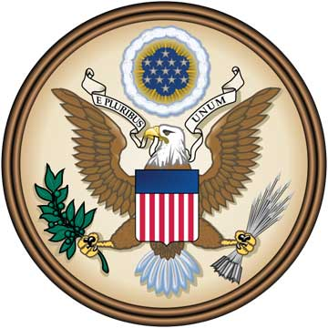
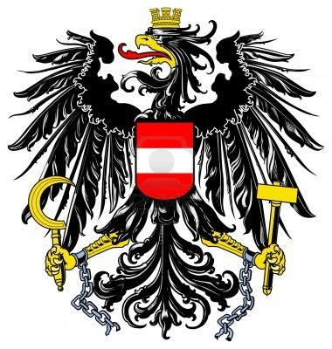
Design your own national symbol

Directions: You are an artist in a nation that has just freed itself from foreign rule. The new government is asking you to design a symbol that will show what your country stands for. It’s up to you to design the symbol that best suits the spirit of your people. Will your symbol by peaceful or warlike, dignified or joyful? Or will it be a combination of these and other qualities?
Your symbol should demonstrate:
- The values and goals of your new country
- Symbols that represent your country’s:
  - Past
  - Future
  - Land
  - Goals
- Design with words that express values
- Paragraph (you may write the paragraph explanation of your symbol on the back)
  - Paragraph should give a quick background story and explanation of your national symbols.
In addition, your national symbol should be neat, colorful, and have an explanation of the symbols, values, and or/goals that are represented on it.
Have fun! Be creative! This will count as a Quiz grade and should look professional. Paper and some crayons/markers etc. will be provided. Be prepared to present your symbol. You can work in a pairs but no more than a group of two.

