Sample Timeline- (YOURS WILL NOT BE DONE ON THE COMPUTER- PAPER WILL BE PROVIDED. You MUST print pictures out before class on Friday)
Topic- Protestant Reformation (Your topic will be a country/area and the major events Pre-WWI)

Act of Supremacy- 1534
1517
Your ending will be
1914
This act was when King Henry broke from the Catholic Church… etc.

1534

Event Title- 95 Thesis
Description- Martin Luther posts his 95 Thesis on the door of a German church. This document stated his 95 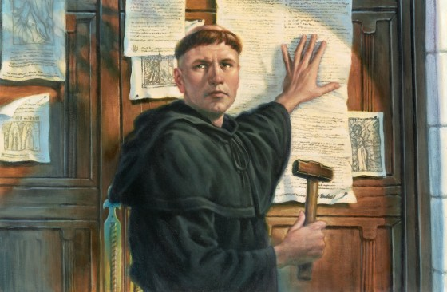complaints against the Catholic Church. This event was important because it began the Protestant Reformation.

