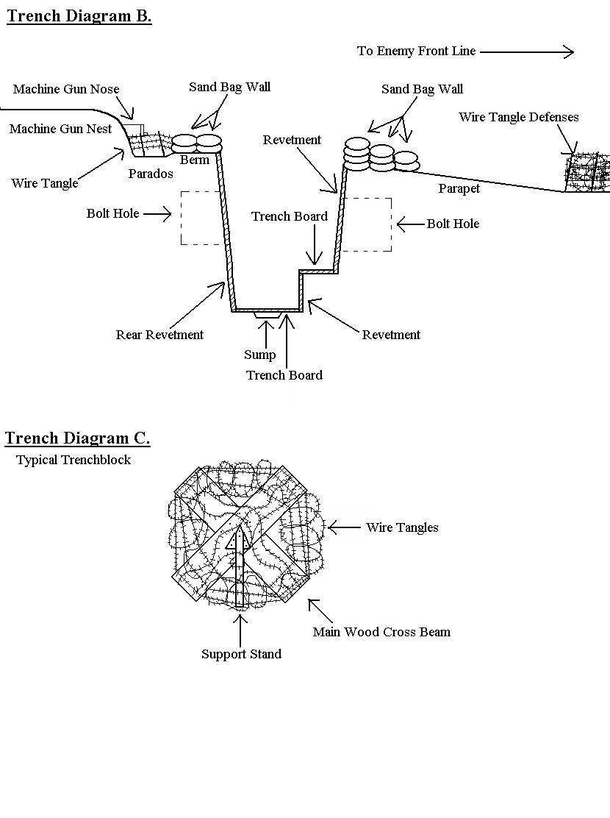

© 2002 [www.historyonthenet.co.uk](http://www.historyonthenet.co.uk)